**User manual Python code and Excel file | Alexis Barou| SAE 15 | RT1 A1**



1. **Opening and editing the Python program**

To open the program, you need to install ***Spyder*** or Visual ***Studio Code*** on your computer.

And make some changes before launching the program:

* Change the path where the ".txt" file to be processed is located (This line indicates the opening of the file).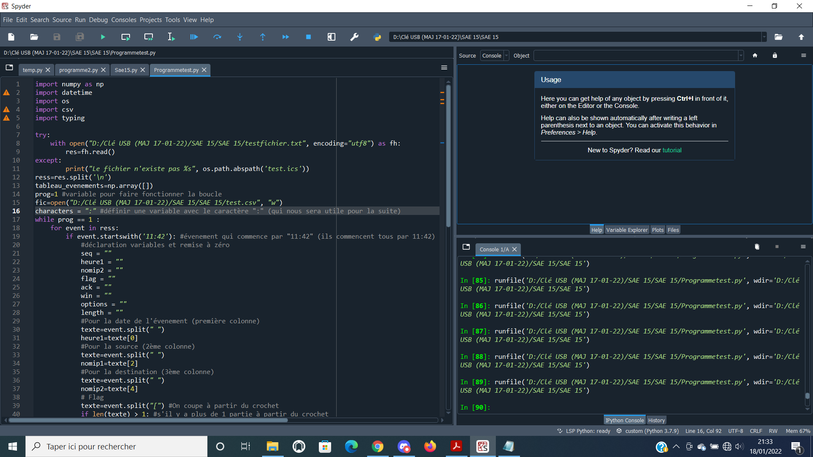
* Change the path where the ".csv" file is located, in which the results of the program will be displayed and stored in an ***Excel*** table.

If your ".csv" file does not exist, it will still be created in the location indicated in your program (with the name "test.csv").

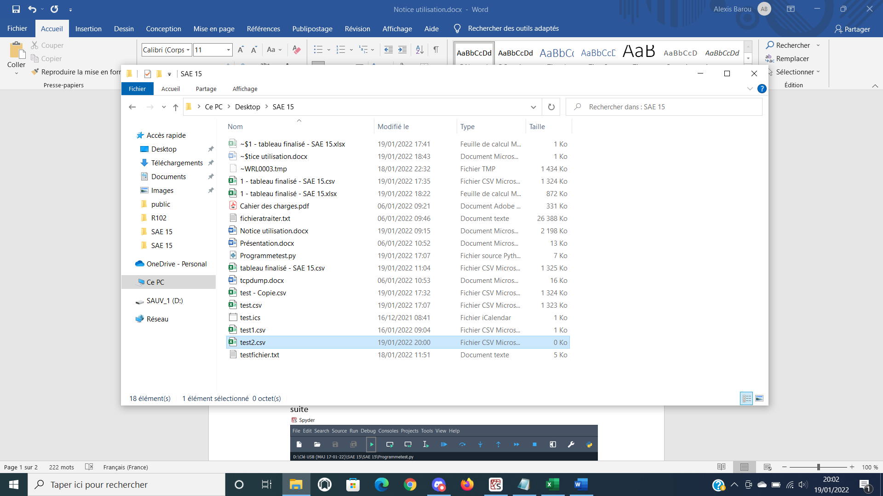

* Change the content "event.startswith" if you want to process another document (by the beginning of your last line of your file)

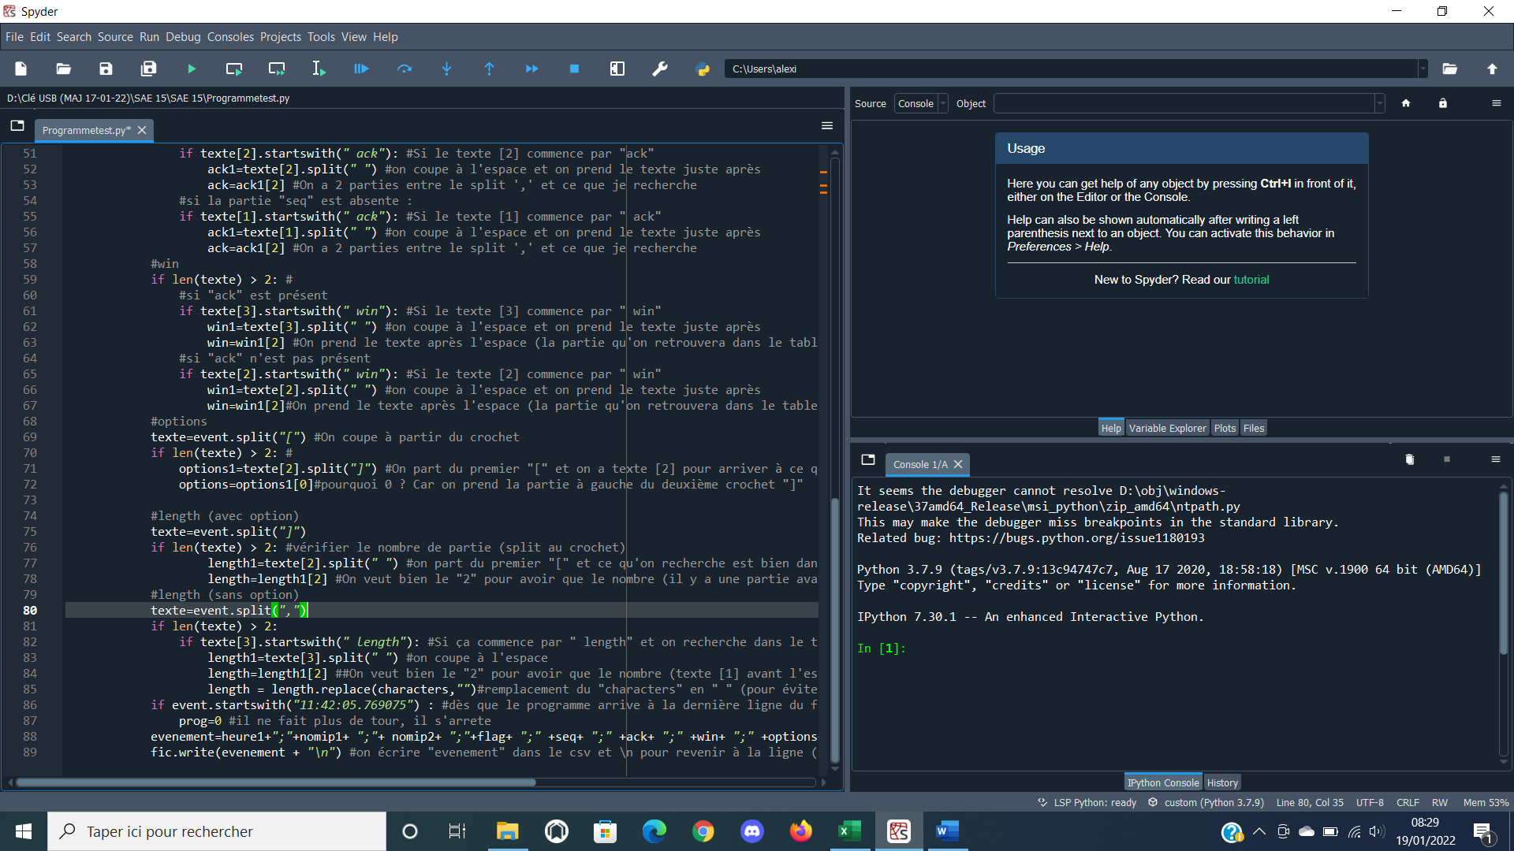

We can move on to the next step

1. **Launch of the program**



To run the program, you need to press the button 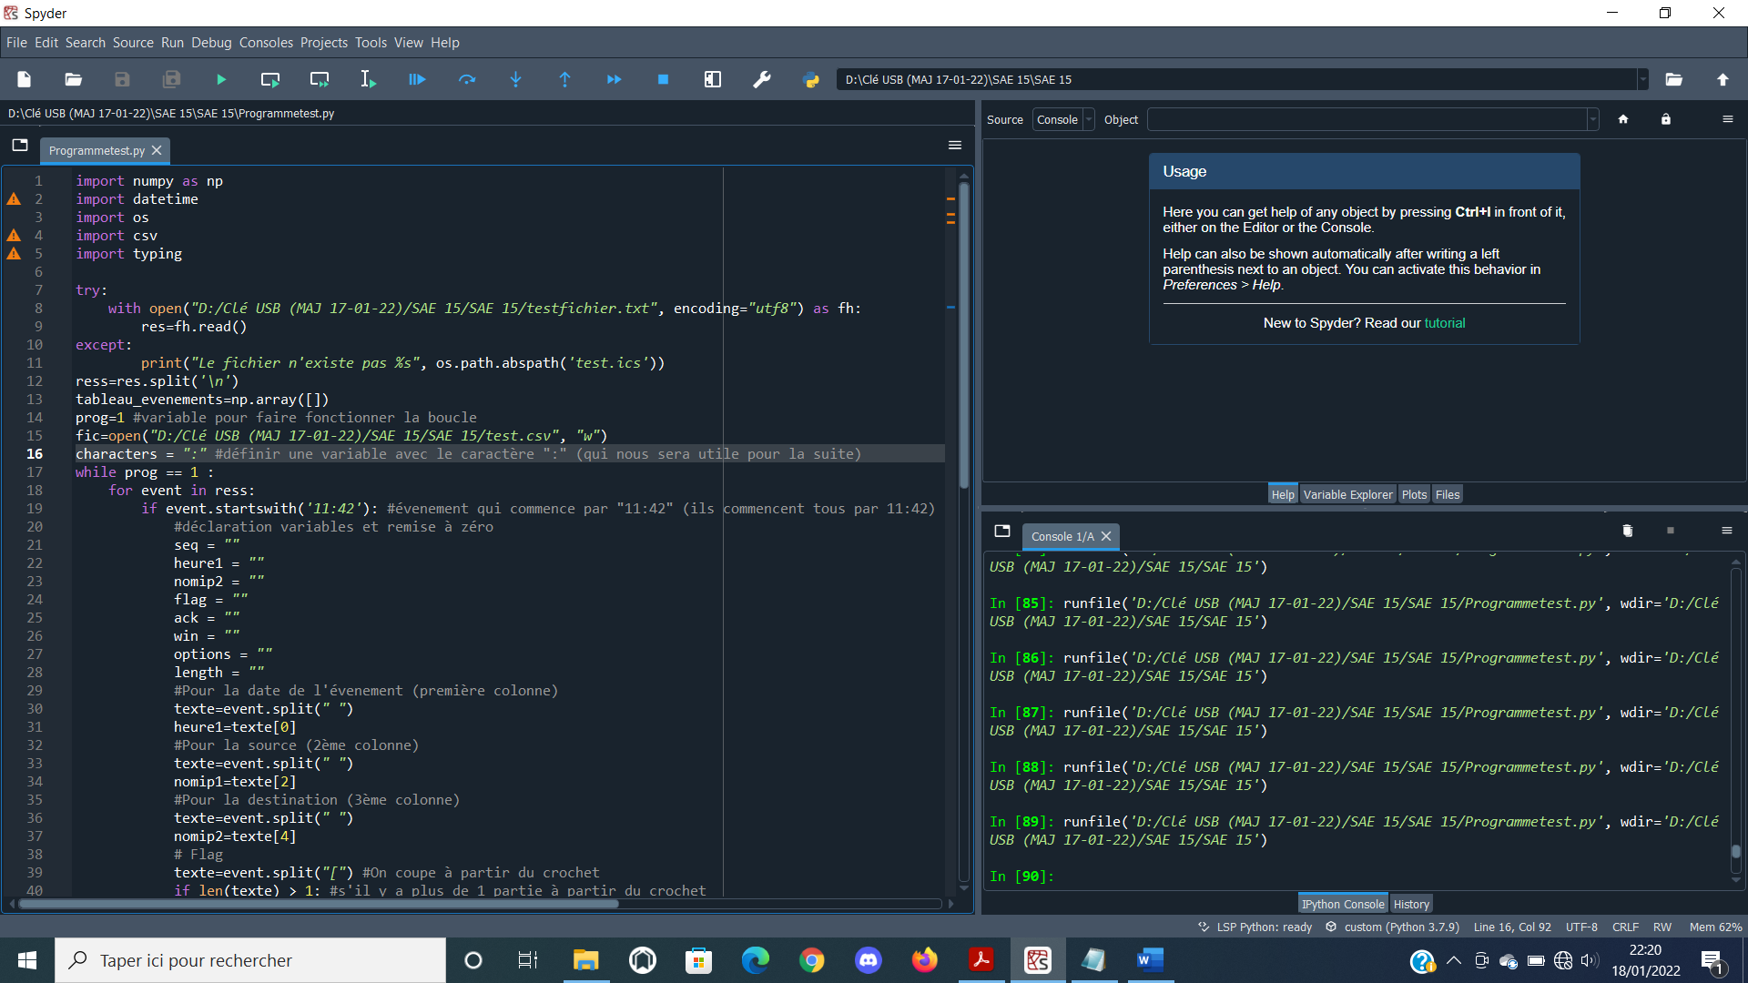 2 times in a row



The part at the bottom right of the screen shows you if you have a problem with your file Python.

If you have no errors, the console will write "runfile...» in green (see photo below)

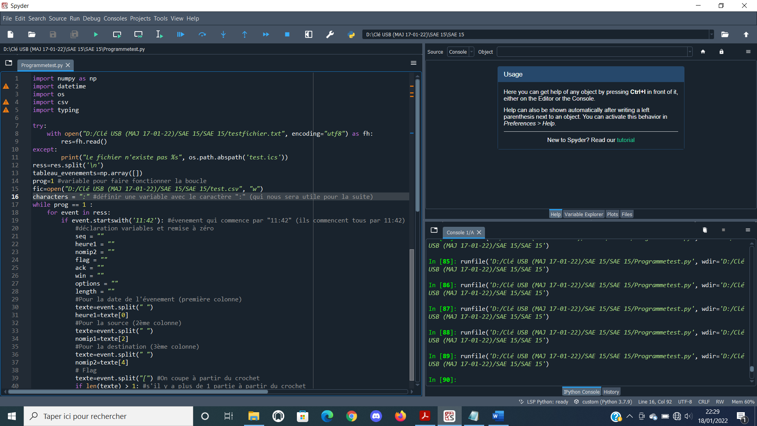

1. **Result on Excel**

Open the ".csv" file that contains the results:

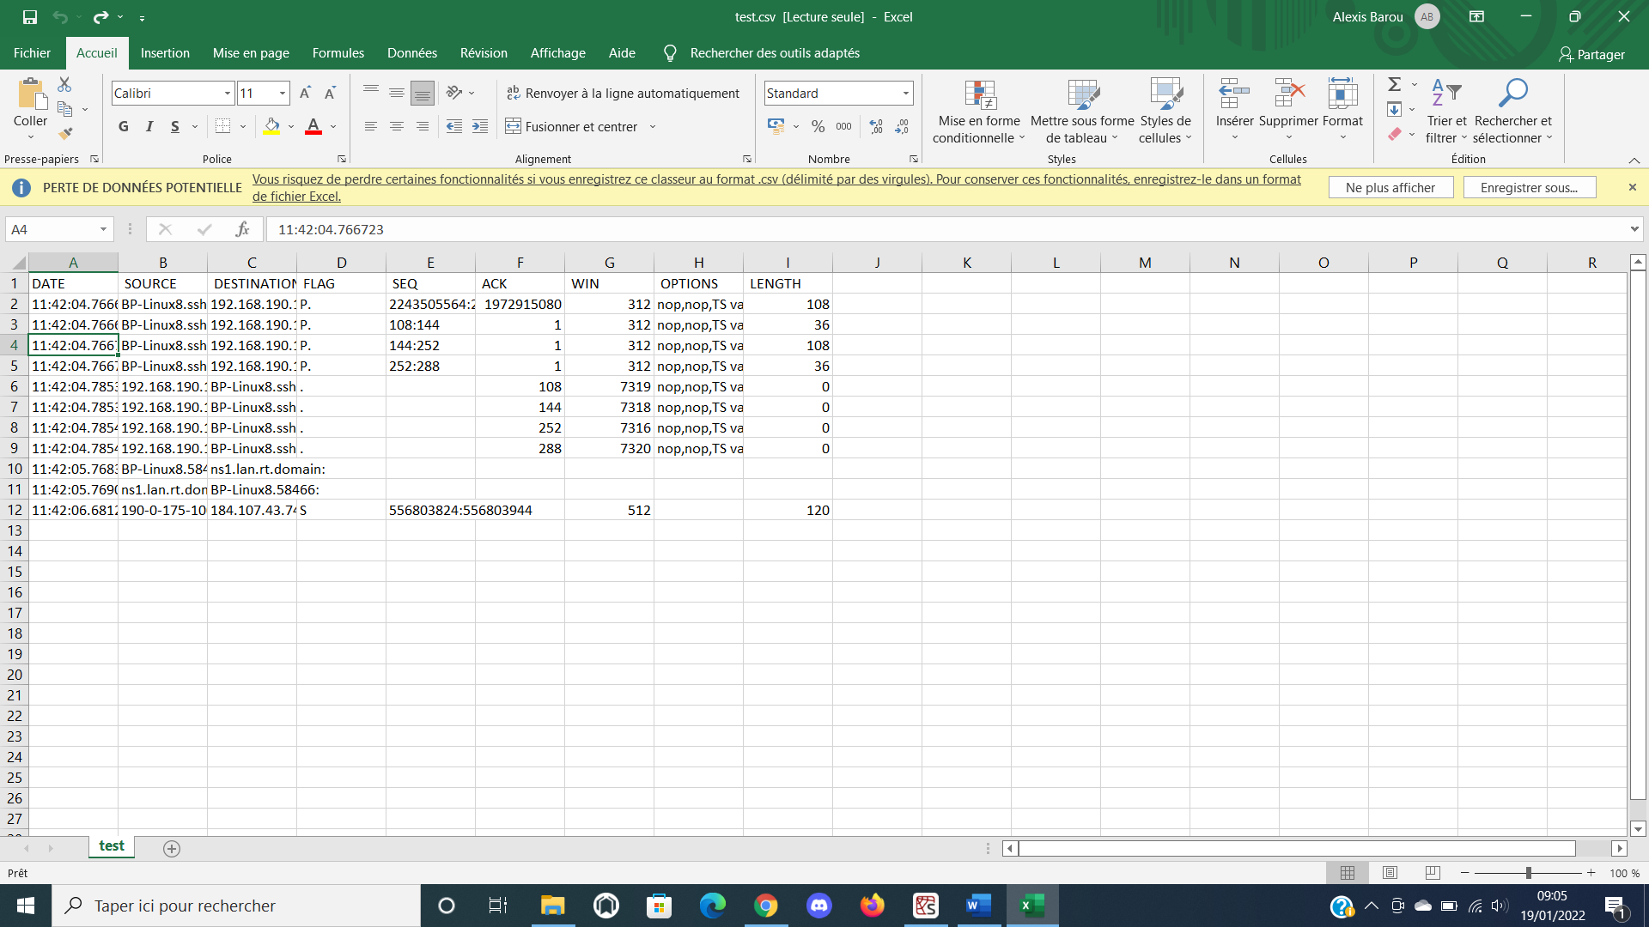

The variables are displayed in the spreadsheet. Semicolons are there to separate with columns

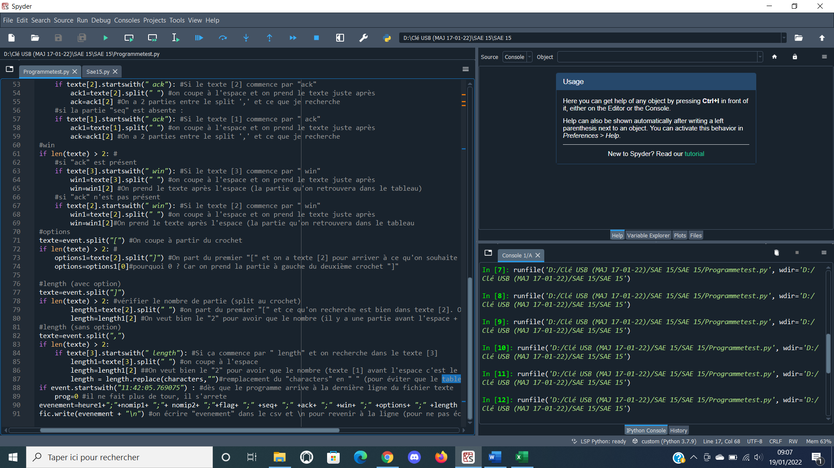

To add the headings for each column:

